Dennis Adiwinata Irwan Soeroso

A11.2021.13225

**Praktikum Minggu 2**

1. **HTML Attributs**

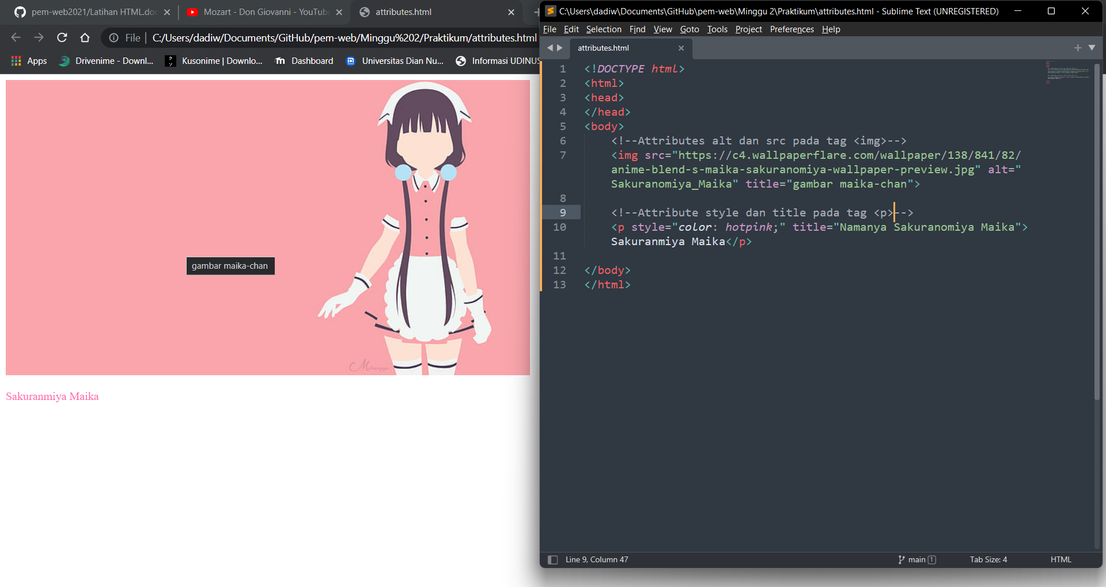

1. **Headings, Rules, & Comments**

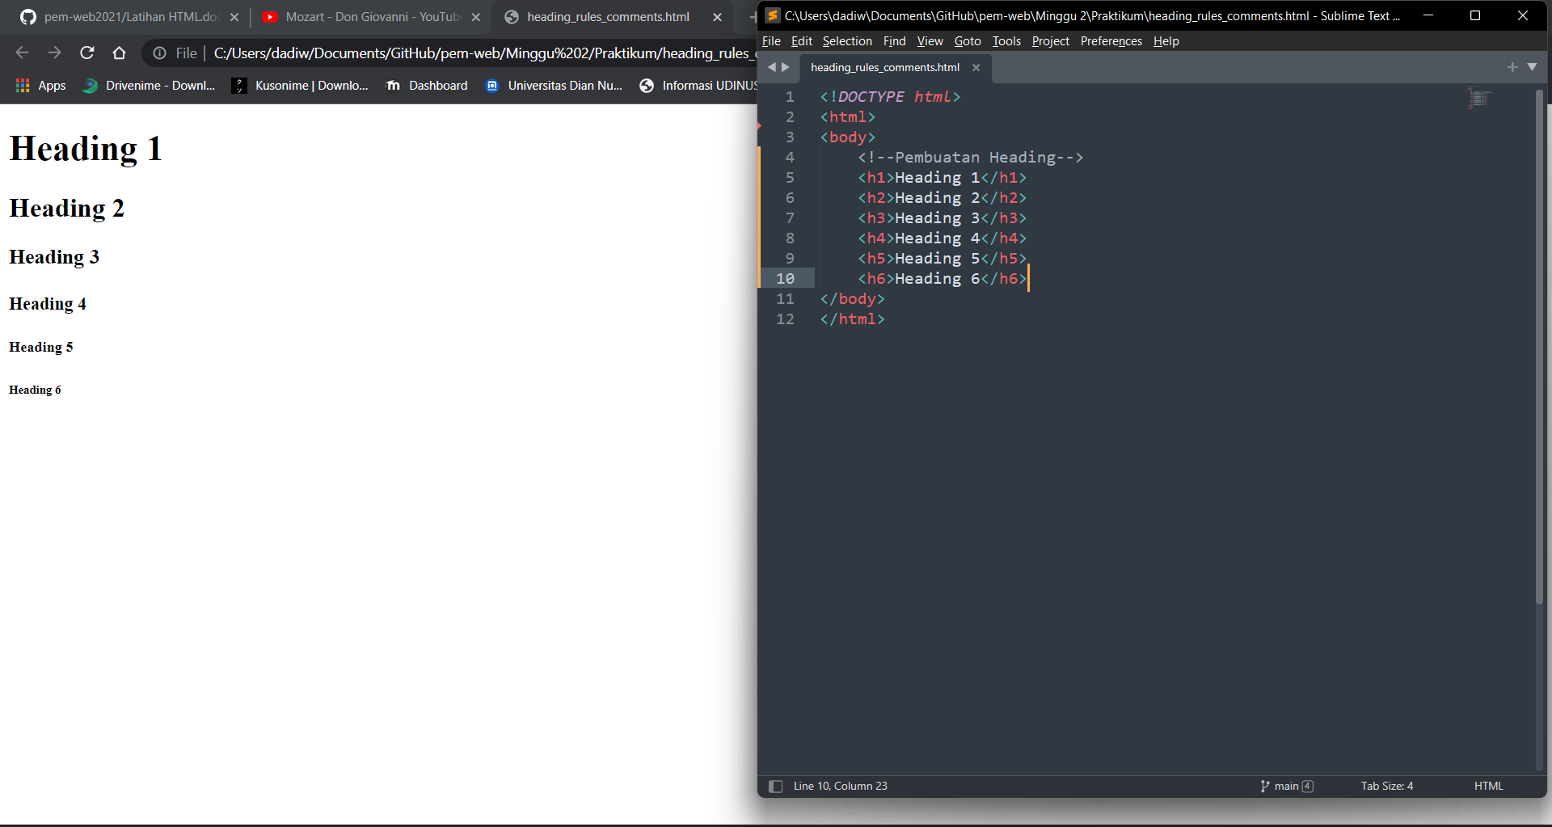

1. **Paragraf**

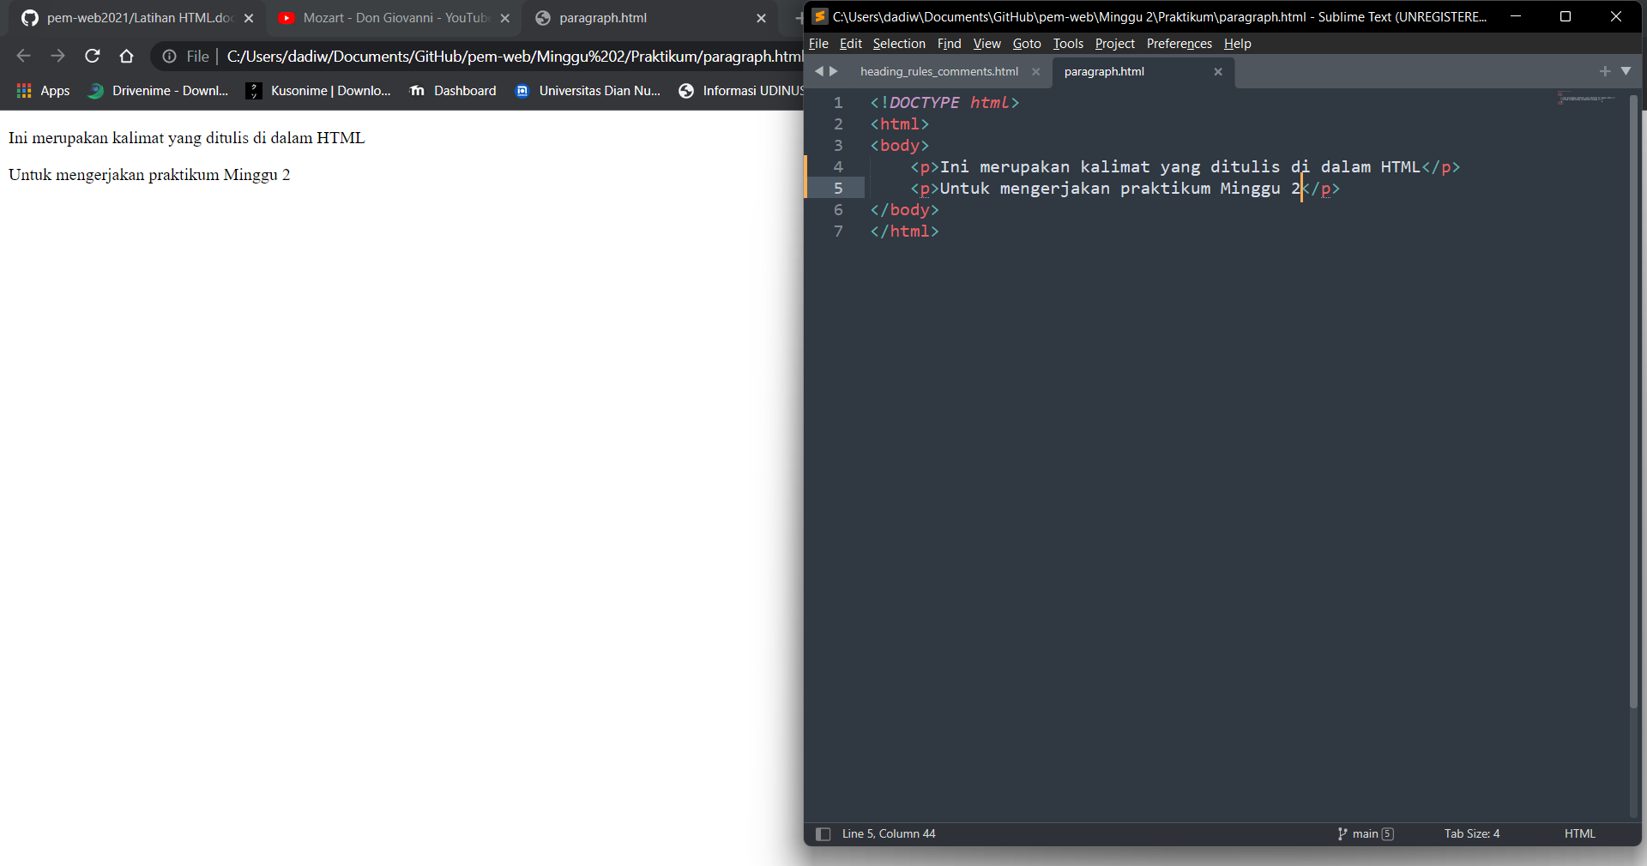

1. **Text Formatting**

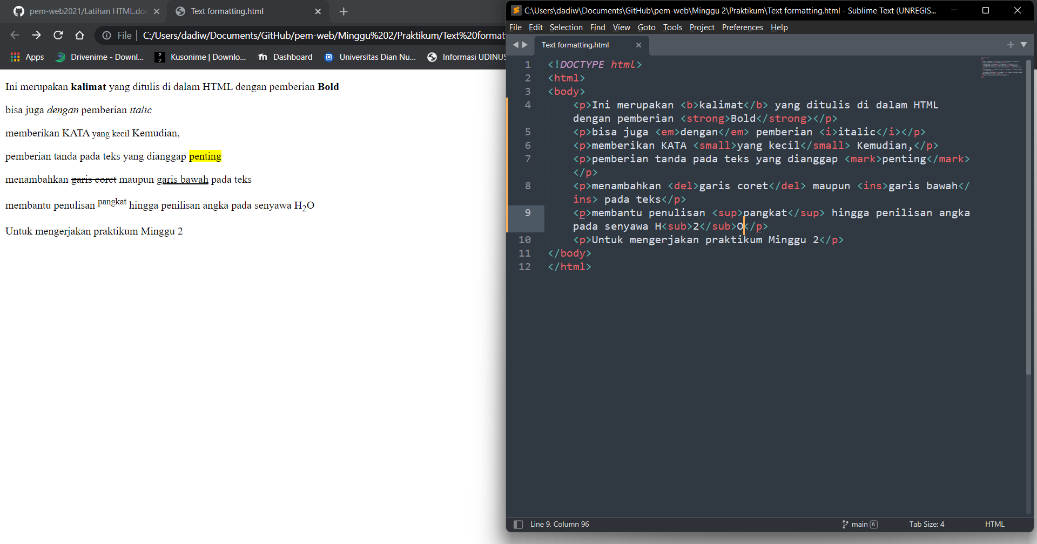

1. **Styles**

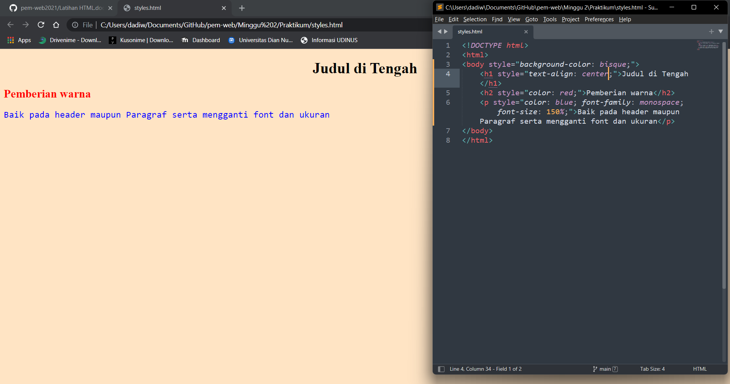

1. **Links**

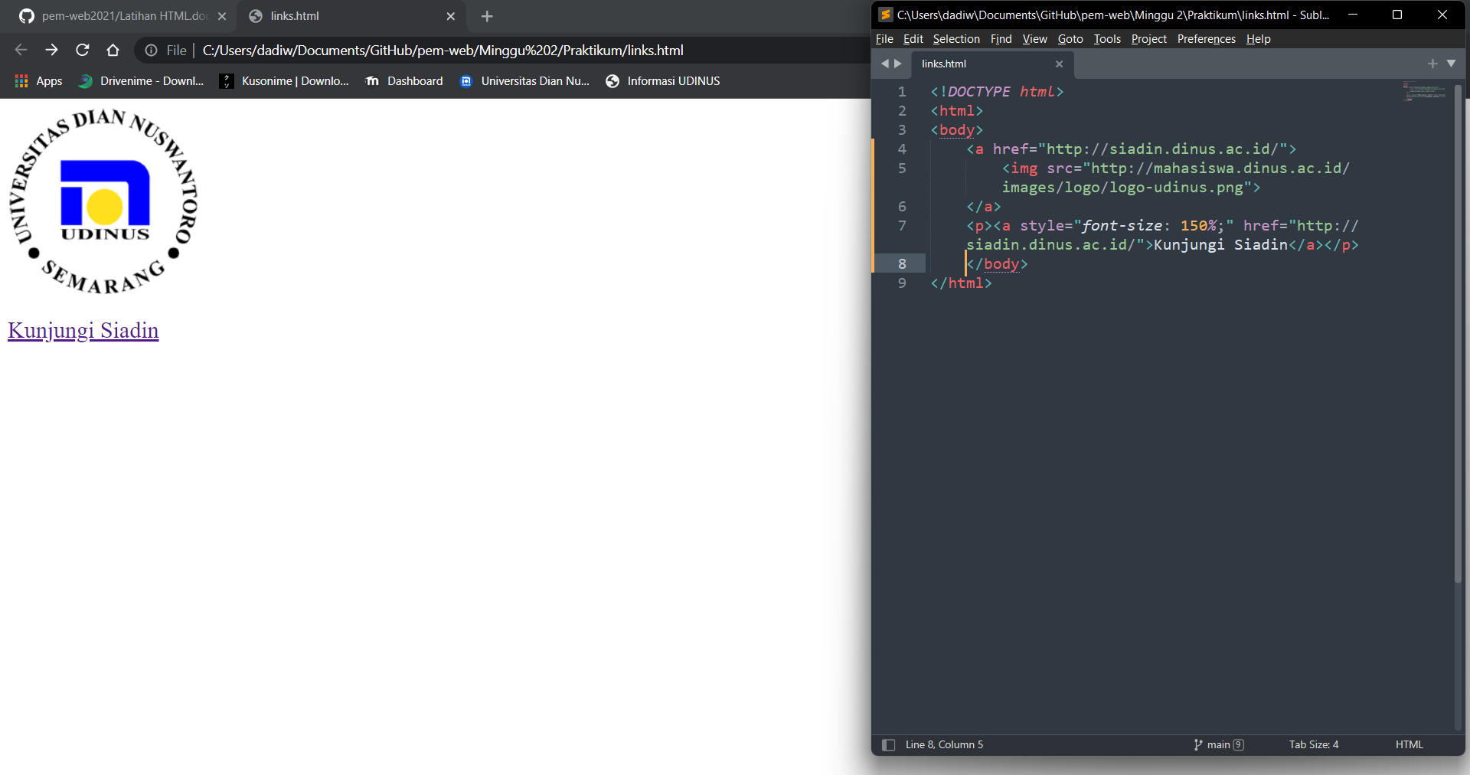

1. **Images**

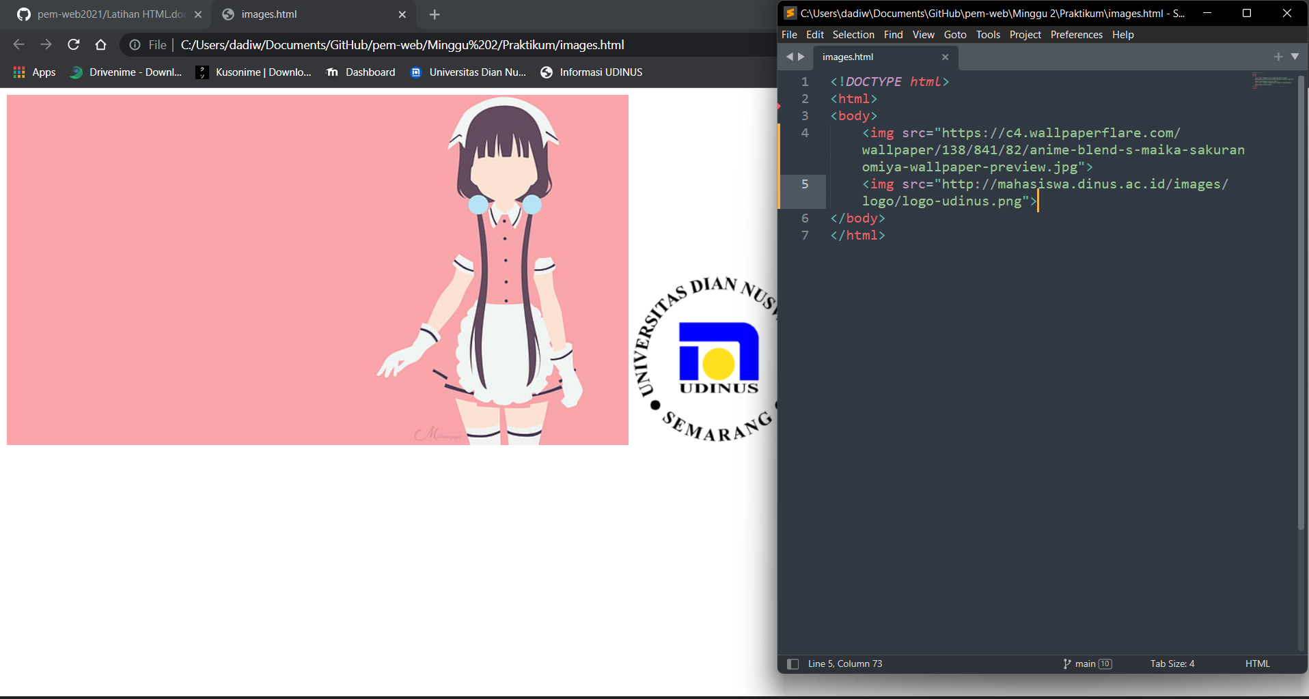

1. **Tables**

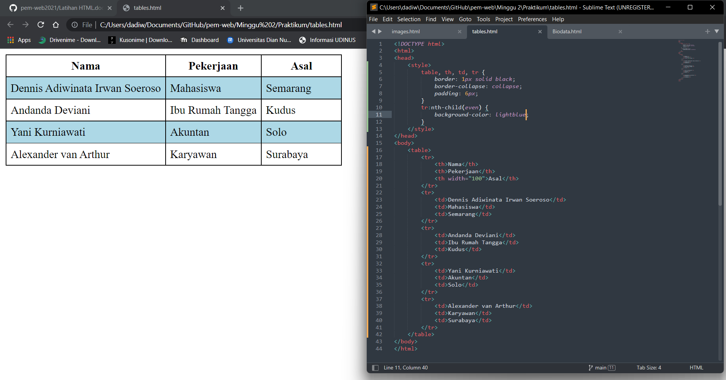

1. **Lists**

